**List of errors in testing admin site**

1. a) When we try to upload new media to the media section we can see broken picture.

b) Also we are unable to use the change date function shown in second image below.

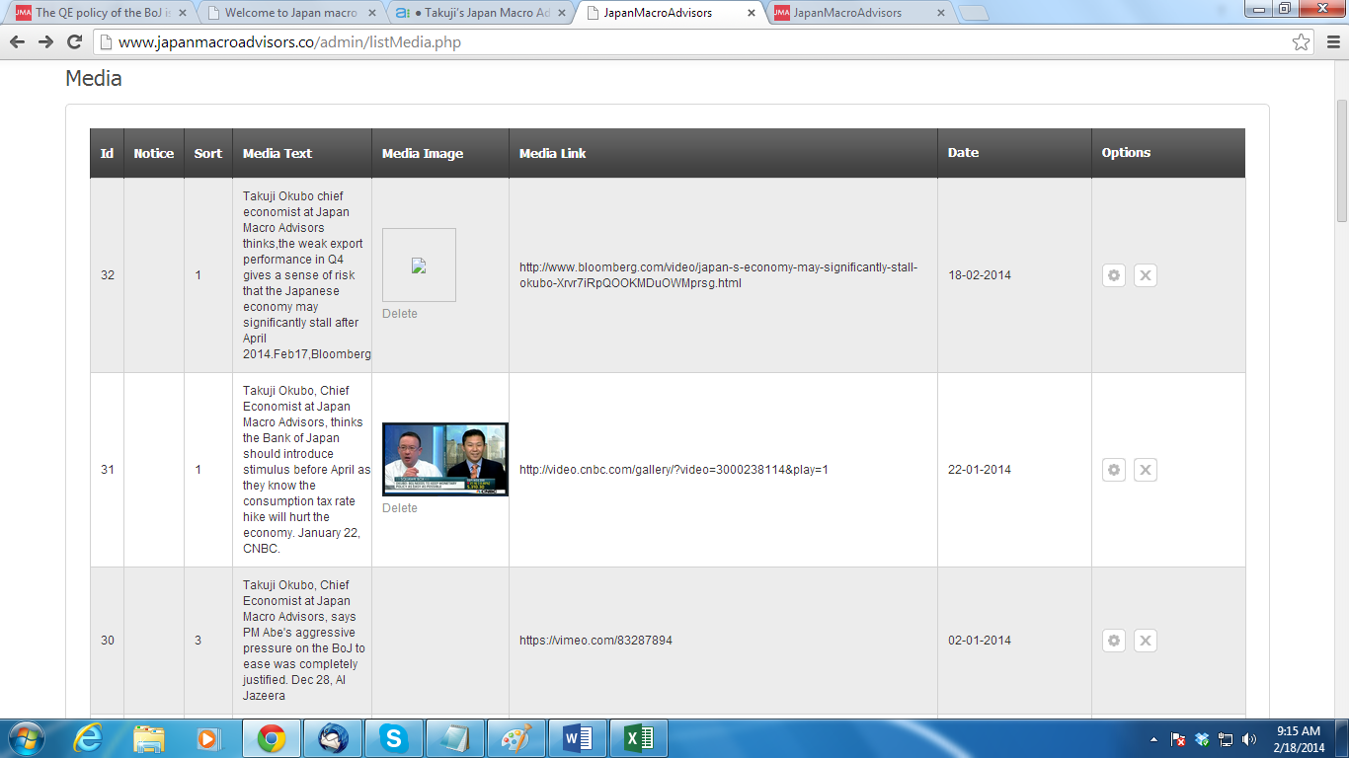

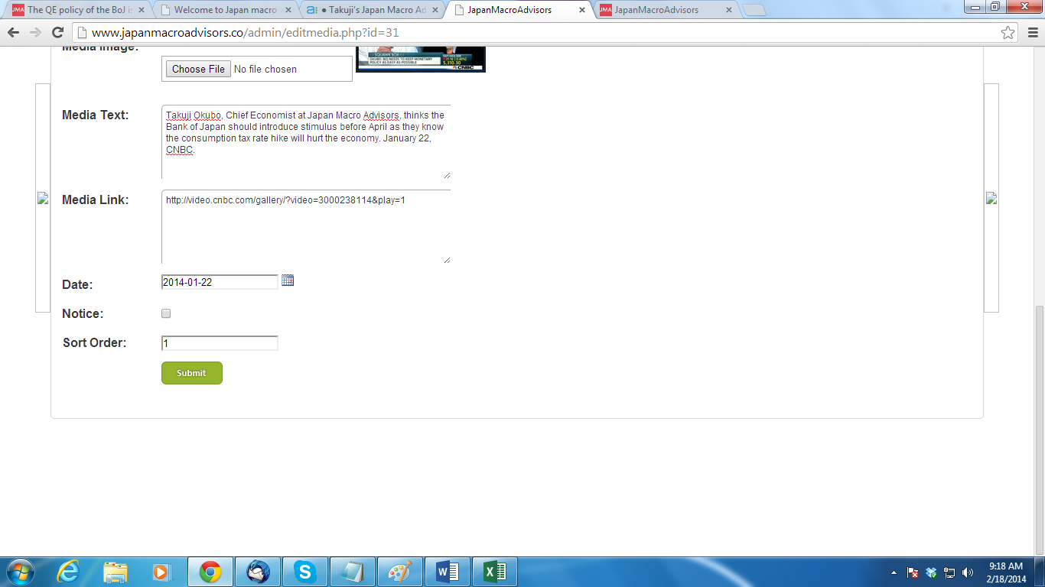

1. In the image below, we can see January calendar shown on the top left hand side of the testing admin page. We do not see error in our live site.

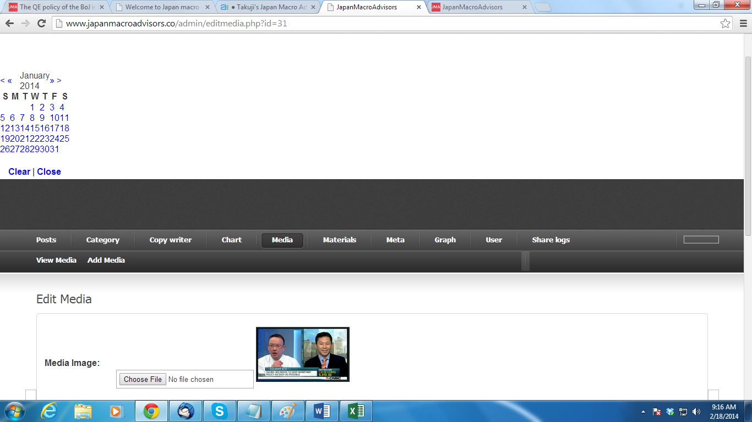

1. In the category section when we are making any post as “New” it is not reflecting in the testing site page under economic indicators as “New”.
2. Under JMA brief Series, we see broken image for the pension report. We need to put image of a house key with family as shown below



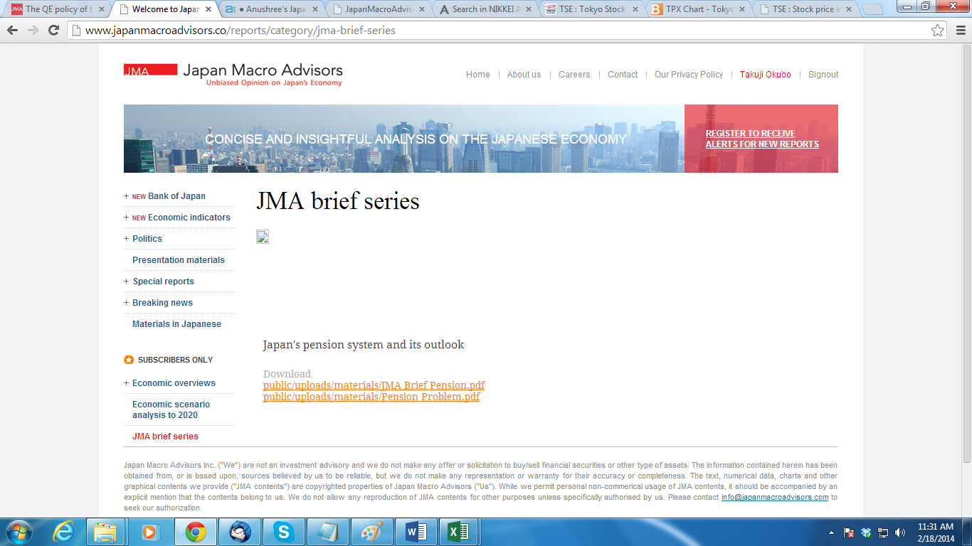

1. Under Category section, we see the order number is not distinct rather same for all indicators which are under economic overviews.

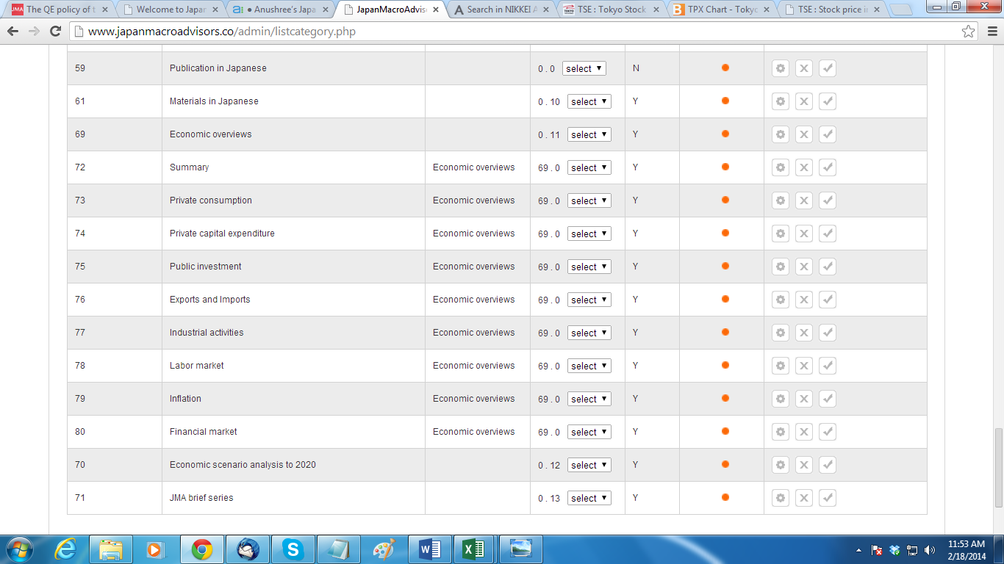

1. Images under economic scenario analysis 2020 is broken. When we try to upload it in admin site we failed to do as it shows red bug (same as in case of point 1 listed above) while uploading image.

